Maven Build Tool, POM Structure, Phases/Goals, Repository Types and Archetypes

⭐ 1. Maven Build Tool
Apache Maven is a project management and build automation tool mainly used in Java projects.
It helps you:
- Build your project (compile, test, package)
- Manage dependencies (external libraries)
- Maintain consistent project structure
- Generate documentation, reports
- Automate deployment
It follows the principle: “Convention over Configuration”
This means Maven has standard project structures, so you need less configuration.
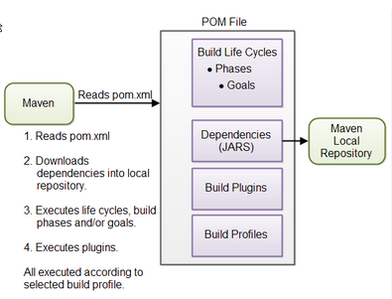

⭐ 2. POM (Project Object Model) Structure
pom.xml is the heart of a Maven project.
It contains project information, dependencies, plugins, and build details.

Basic Structure of POM

Important POM Elements
Tag | Description
groupId | Unique company/project ID (e.g., com.mycompany)
artifactId | Name of the project/module
version | Version number (e.g., 1.0.0)
packaging | jar / war / pom
dependencies | External libraries
build | Plugins, compilation config
repositories | External repo information
properties | Java version, encoding, etc.

Example of POM flle:
<project xmlns="http://maven.apache.org/POM/4.0.0"
xmlns:xsi="http://www.w3.org/2001/XMLSchema-instance"
xsi:schemaLocation="http://maven.apache.org/POM/4.0.0
http://maven.apache.org/xsd/maven-4.0.0.xsd">

<modelVersion>4.0.0</modelVersion>

<groupId>com.example</groupId>
<artifactId>myapp</artifactId>
<version>1.0-SNAPSHOT</version>
<packaging>jar</packaging>

<dependencies>
<!-- Dependencies go here -->
</dependencies>

<build>
<plugins>
<!-- Build plugins go here -->
</plugins>
</build>
</project>

⭐ 3. Maven Lifecycle, Phases, and Goals

Maven Build System Architecture.

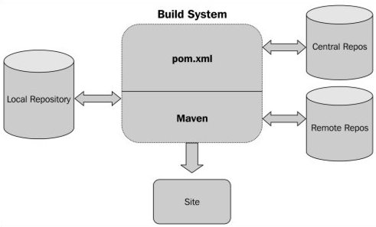

Summary of the Diagram
- The Maven Build System sits at the center.
- It reads pom.xml to understand project needs.
- It interacts with:
  - Local Repository ← first place to look for dependencies
  - Remote & Central Repositories ← online sources for dependencies
- After completing the build process, Maven can generate a site/documentation.

3.1 Maven Lifecycles
Maven has 3 main lifecycles:
1️⃣ clean – cleans previous build
2️⃣ default – builds the project
3️⃣ site – generates documentation

3.2 Common Maven Phases (default lifecycle)
Phase | Purpose
validate | Validate project structure
compile | Compile source code
test | Run unit tests
package | Creates JAR/WAR
verify | Integration test checks
install | Install to local repo
deploy | Deploy to remote repo

3.3 Goals
A goal is a specific task.
Example:
- mvn clean → runs "clean" goal
- mvn compile → runs "compiler:compile" goal
- mvn package → runs packaging goal

⭐ 4. Maven Repository Types
Maven stores dependencies in repositories.

1. Local Repository
- Located in your system
- Path: ~/.m2/repository
- Stores downloaded dependencies
- Fastest access

2. Central Repository
- Provided by Maven community
- Contains commonly used libraries
- URL: Maven Central
- Automatically downloaded when needed

3. Remote Repository
- Maintained by third parties or companies
Examples:
- Spring Repo
- JBoss Repo
- Corporate Nexus/Artifactory
Maven checks repositories in this order:
Local → Remote → Central

⭐ 5. Maven Archetypes
Archetype = project template (predefined structure).
Used to quickly create a new project structure.

Common Archetypes:
Archetype | Description
maven-archetype-quickstart | Creates a basic Java project
maven-archetype-webapp | Creates a Java Web project (with web.xml)
maven-archetype-j2ee-simple | Simple J2EE project
spring-boot-archetype | Spring Boot starter template

Overview of ORM & JPA, JDBC vs Hibernate, Hibernate Architecture

1. Overview of ORM & JPA

1.1 What is ORM?
ORM (Object–Relational Mapping) is a technique that maps Java objects to database tables.

ORM Purpose
- Automatically converts Java objects ↔ database rows
- Eliminates writing large SQL queries
- Allows developers to work with objects, not SQL

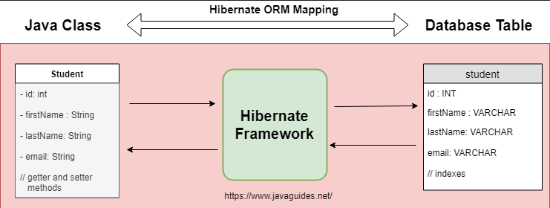

Benefits of ORM
- Faster development
- Less boilerplate code
- Automatic table creation
- Transaction management
- Database independence (MySQL, Oracle, etc.)

1.2 What is JPA?
JPA (Java Persistence API) is a specification (interface) provided by Java to manage relational data using ORM.
JPA is NOT a framework—it is a set of rules.

JPA Provides
- Annotations like @Entity, @Table, @Id
- Entity Manager API
- Query language (JPQL)

Popular Implementations of JPA
- Hibernate (most widely used)
- EclipseLink
- OpenJPA
So, JPA = rules
Hibernate = tool that follows these rules
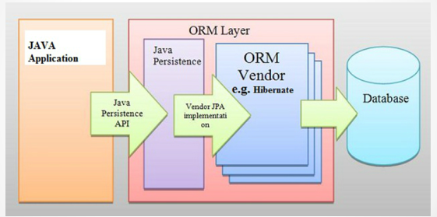

⭐ 2. JDBC vs Hibernate
Feature | JDBC | Hibernate
SQL Handling | Manual SQL writing | Auto SQL generation
Mapping | Maps manually | Auto maps Java objects ↔ tables
Boilerplate Code | High (connection, statement, resultset) | Very low
Caching | No caching | Supports Level-1 & Level-2 caching
Transactions | Manual | Automatic
Relationships | Hard to handle (joins manually) | Very easy (@OneToMany, etc.)
Lazy Loading | Not supported | Supported
Database Independence | Low | High (dialects)
Error Handling | Programmer responsibility | Framework handles many errors

Summary
- JDBC → Low-level, lots of SQL, manual work
- Hibernate → High-level ORM, less SQL, more automation

3. Hibernate Architecture
Hibernate follows a Layered Architecture to manage database operations.
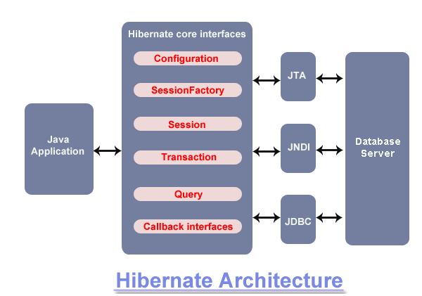
Here are the major components:

3.1 Configuration
- Reads hibernate.cfg.xml
- Loads database connection details
- Loads mapping files or annotations

3.2 SessionFactory
- Heavyweight object
- Created once per application
- Thread-safe
- Used to create Session objects

3.3 Session
- Lightweight object
- Represents a connection to the database
- Used for CRUD operations
- Not thread-safe
- Provides methods: save(), update(), delete(), createQuery()

3.4 Transaction
- Manages commits and rollbacks
- Ensures data consistency
- Example:
Transaction tx = session.beginTransaction();
tx.commit();

3.5 Query Interface
Hibernate supports:
- HQL (Hibernate Query Language)
- JPQL (Java Persistence Query Language)
- Criteria API
- Native SQL

3.6 Mapping Metadata
Defines mapping between:
- Java classes ↔ database tables
- Fields ↔ columns
- Relationships (@OneToMany, @ManyToMany, etc.)
Stored in:
- Annotations (recommended)
- XML mapping files

